# Introduction

Use this document to troubleshoot problems with viewers in IBM Content Navigator. This document includes a series of flowcharts that you can use to identify the cause and appropriate solution for the problem that you are encountering.

When a solution is not available, the document includes a list of the information that you need to collect before calling IBM Software Support.

Frequently, problems with viewers and viewing features occur for one of the following reasons:

* You have a problem with your IBM Content Navigator configuration
* You have a problem with your IBM Content Navigator web application server configuration
* The viewer is not supported on your operating system
* The file type is not supported by the viewer that you are using

# Troubleshooting problems with viewing features

IBM Content Navigator includes features that enable users to preview documents as thumbnails and download documents as PDF files. Use the topics in this section to troubleshoot problems with these viewing features.

## Document thumbnails are not displayed in the document information pane

When users select a document in the browse view or the search results, users can see a thumbnail of the document in the document information pane.

Use the following flowchart to determine why document thumbnails are not displayed in the document information pane.

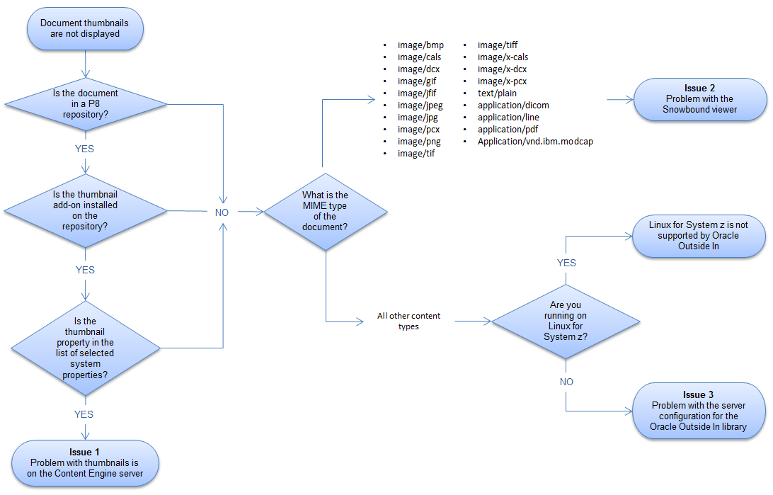

*Figure 1 - Flowchart for determining why document thumbnails are not displayed*

|  |  |  |
| --- | --- | --- |
|  | You have determined that the problem is with… | What to do next… |
| 1 | Thumbnails on the Content Engine server | Review the IBM FileNet P8 documentation for configuring thumbnails on Content Engine. For more information, see [Creating a thumbnail generation job sweep](http://pic.dhe.ibm.com/infocenter/p8docs/v5r2m0/topic/com.ibm.p8.ce.admin.tasks.doc/p8pcc164.htm). |
| 2 | The Snowbound viewer | Enable debug logging on the IBM Content Navigator server and contact IBM Software Support. For more information, see [Enabling server logging for IBM Content Navigator](http://pic.dhe.ibm.com/infocenter/p8docs/v5r2m0/topic/com.ibm.installingeuc.doc/eucts002.htm). |
| 3 | The server configuration for the Oracle Outside In library | Review the troubleshooting diagram in Troubleshooting problems with the Oracle Outside In library. |

## Documents are not displayed or downloaded as PDF files

Some documents are automatically converted to PDF files when users view or download the files. The conversion to PDF is handled by one of the following mechanisms:

* The AFP2PDF viewer
* The **Download as PDF** option in the web client

Use the following flowchart to determine why documents are not displayed or downloaded as PDF files.

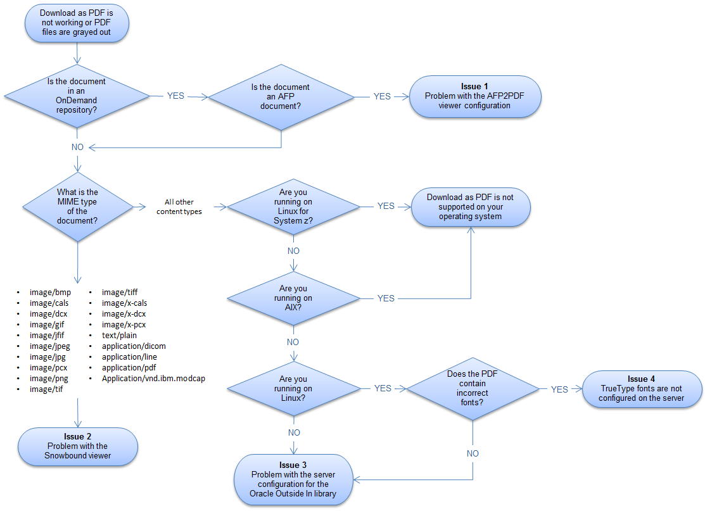

*Figure 2 - Flowchart for determining why documents are not displayed or downloaded as PDF files*

|  |  |  |
| --- | --- | --- |
|  | You have determined that the problem is with… | What to do next… |
| 1 | AFP2PDF viewer configuration | Review the troubleshooting diagram in AFP2PDF conversion viewer. |
| 2 | The Snowbound viewer | Enable debug logging on the IBM Content Navigator server and contact IBM Software Support. For more information, see [Enabling server logging for IBM Content Navigator](http://pic.dhe.ibm.com/infocenter/p8docs/v5r2m0/topic/com.ibm.installingeuc.doc/eucts002.htm). |
| 3 | The server configuration for the Oracle Outside In library | Review the troubleshooting diagram in Troubleshooting problems with the Oracle Outside In library. |
| 4 | TrueType fonts are not configured on the server | See Configuring TrueType fonts. |

# Troubleshooting problems with viewers

## HTML conversion viewer

The HTML conversion viewer is used to open document in the user’s web browser. The HTML conversion viewer is also used to generate previews of documents in the web client.

Use the following flowchart to determine why the HTML conversion viewer is not displaying documents.

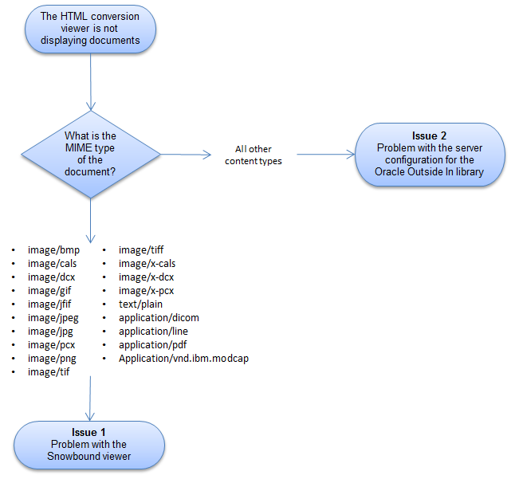

*Figure 3 - Flowchart for determining why the HTML conversion viewer is not working*

|  |  |  |
| --- | --- | --- |
|  | You have determined that the problem is with… | What to do next… |
| 1 | The Snowbound viewer | Enable debug logging on the IBM Content Navigator server and contact IBM Software Support. For more information, see [Enabling server logging for IBM Content Navigator](http://pic.dhe.ibm.com/infocenter/p8docs/v5r2m0/topic/com.ibm.installingeuc.doc/eucts002.htm). |
| 2 | The server configuration for the Oracle Outside In library | Review the troubleshooting diagram in Troubleshooting problems with the Oracle Outside In library. |

## Ajax viewer

The Ajax viewer is used to display multiple types of documents that are stored on IBM Content Manager and IBM Content Manager OnDemand repositories.

Use the following flowchart to determine why the Ajax viewer is not displaying documents.

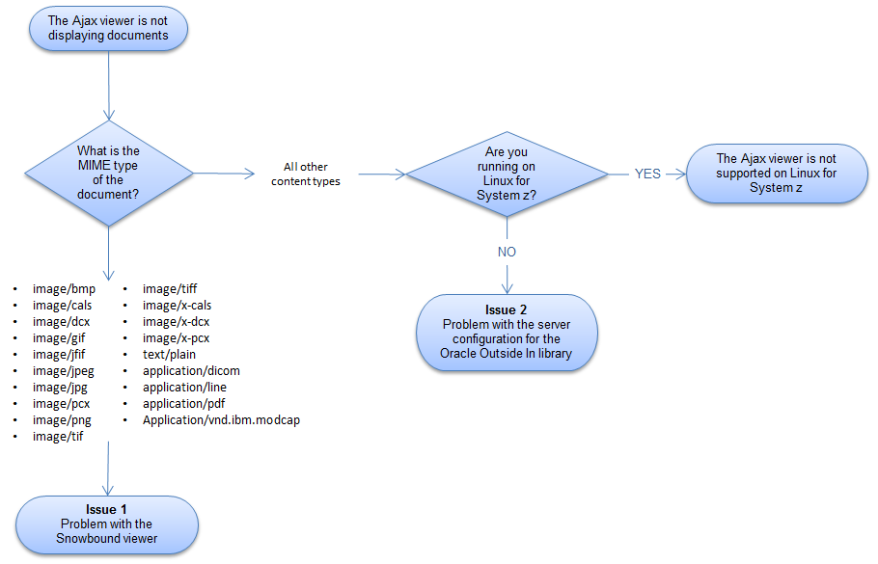

*Figure 4 - Flowchart for determining why the Ajax viewer is not working*

|  |  |  |
| --- | --- | --- |
|  | You have determined that the problem is with… | What to do next… |
| 1 | The Snowbound viewer | Enable debug logging on the IBM Content Navigator server and contact IBM Software Support. For more information, see [Enabling server logging for IBM Content Navigator](http://pic.dhe.ibm.com/infocenter/p8docs/v5r2m0/topic/com.ibm.installingeuc.doc/eucts002.htm). |
| 2 | The server configuration for the Oracle Outside In library | Review the troubleshooting diagram in Troubleshooting problems with the Oracle Outside In library. |

## PDF conversion viewer

The PDF conversion viewer is used to convert multiple types of documents to PDF when users open the documents from IBM Content Navigator.

Use the following flowchart to determine why the PDF conversion viewer is not displaying documents.

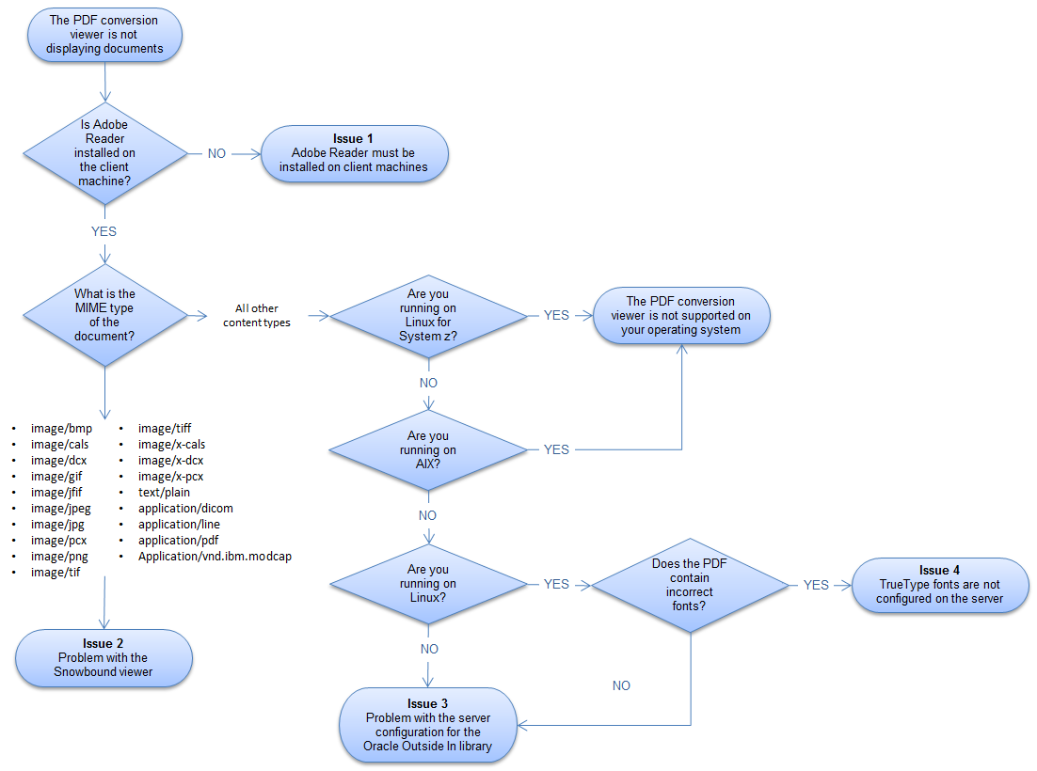

*Figure 5 - Flowchart for determining why the PDF conversion viewer is not working*

|  |  |  |
| --- | --- | --- |
|  | You have determined that the problem is with… | What to do next… |
| 1 | Adobe Reader is not installed on the machine | Download Adobe Reader from the Adobe support site. |
| 2 | The Snowbound viewer | Enable debug logging on the IBM Content Navigator server and contact IBM Software Support. For more information, see [Enabling server logging for IBM Content Navigator](http://pic.dhe.ibm.com/infocenter/p8docs/v5r2m0/topic/com.ibm.installingeuc.doc/eucts002.htm). |
| 3 | The server configuration for the Oracle Outside In library | Review the troubleshooting diagram in Troubleshooting problems with the Oracle Outside In library. |
| 4 | TrueType fonts are not configured on the server | See Configuring TrueType fonts. |

## AFP2PDF conversion viewer

The AFP2PDF conversion viewer automatically converts AFP documents that are stored on your IBM Content Manager OnDemand repositories to PDF files when users open the documents.

The AFP2PDF conversion viewer is available through the IBM OnDemand Web Enablement Kit. You must install the AFP2PDF conversion viewer on the IBM Content Navigator server and then configure the viewer in the administration tool. For more information, see [Configuring the AFP2PDF conversion viewer](http://pic.dhe.ibm.com/infocenter/p8docs/v5r2m0/topic/com.ibm.installingeuc.doc/eucco057.htm).

To verify that the AFP2PDF conversion viewer is installed and configured, run the verify.jsp tool. For more information, see Verifying your viewer configuration by running the verify.jsp tool.

## FileNet Viewer

The FileNet viewer is used to display multiple types of documents that are stored on IBM FileNet Content Manager and repositories.

Use the following flowchart to determine why the FileNet viewer is not displaying documents.

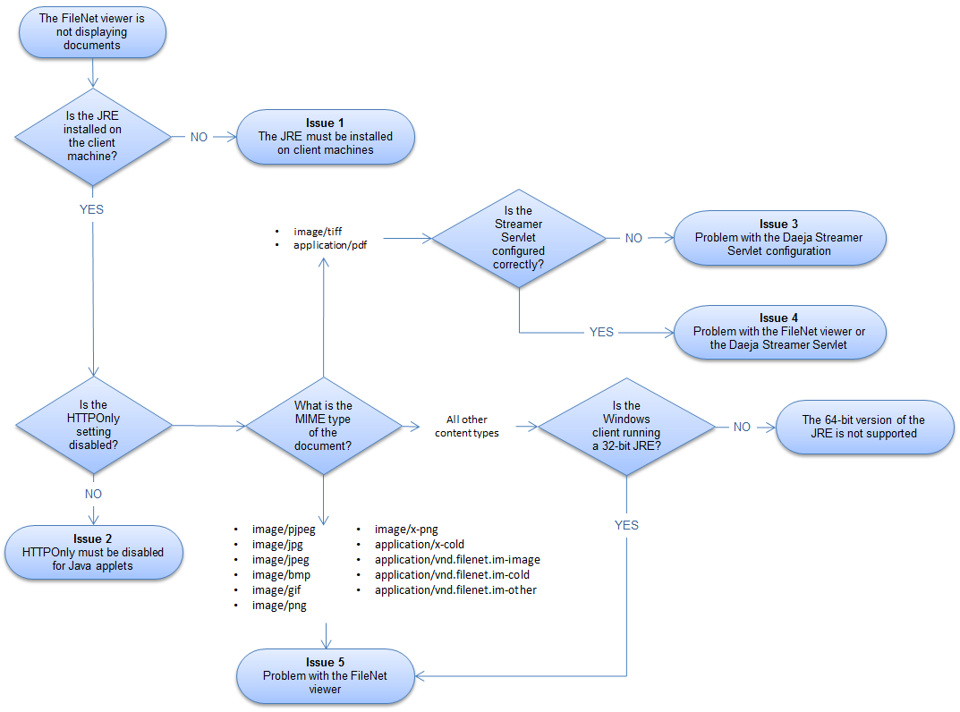

*Figure 6 - Flowchart for determining why the FileNet viewer is not working*

|  |  |  |
| --- | --- | --- |
|  | You have determined that the problem is with… | What to do next… |
| 1 | The JRE is not installed on client machines | Download the Java Runtime Environment (JRE) from the Oracle support site. See the [IBM Content Navigator hardware and software requirements](http://www.ibm.com/support/docview.wss?uid=swg27037865) for information about supported versions of the JRE. |
| 2 | The HTTPOnly setting is not disabled | See Disabling HTTPOnly settings on WebSphere Application Server. |
| 3 | The Daeja Streamer Servlet configuration | See Verifying the Daeja Streamer Servlet configuration. |
| 4 | The FileNet viewer or the Daeja Streamer Servlet | See Enabling trace logging for the Daeja Streamer Servlet and [Enabling trace logging for the FileNet viewer](#_FileNet_(Daeja)_Viewer). |
| 5 | The FileNet viewer | See [Enabling trace logging for the FileNet viewer](#_FileNet_(Daeja)_Viewer). |

### Disabling HTTPOnly settings on WebSphere Application Server

The FileNet viewer uses a Java applet to access the user session cookie (JSESSIONID) on the IBM Content Navigator server. If the HTTPOnly setting is enabled for the JSESSIONID, the Java applet cannot access the user session cookie.

You must disable the HTTPOnly settings in WebSphere Application Server to enable the FileNet viewer to function properly.

To determine whether the HTTPOnly setting is enabled or disabled:

1. Open a debugging tool, such as Firebug, the Chrome browser or debugger, or Fiddler.
2. Enter the URL of your IBM Content Navigator deployment.
3. Review the information that is logged in the debugging tool.   
     
   One of the first few logged HTTP requests should contain a “set cookie” header for the JSESSIONID user session cookie. If the header has the keyword “HTTPOnly” at the end of it, HTTPOnly is enabled, which will prevent the FileNet viewer from working.

For more information, see [Disabling HTTPOnly settings for Java applets](http://pic.dhe.ibm.com/infocenter/p8docs/v5r2m0/topic/com.ibm.installingeuc.doc/eucin019.htm).

### Verifying the Daeja Streamer Servlet configuration

The Daeja Streamer Servlet is used to view TIFF and PDF documents. To verify that the Daeja Streamer Servlet is configured correctly, run the verify.jsp tool and review the ViewONE Pro section of the output.

For more information, see Verifying your viewer configuration by running the verify.jsp tool.

### Enabling trace logging for the Daeja Streamer Servlet

If you determine that there is a problem with your Daeja Streamer Servlet configuration, you should enable trace logging to help diagnose the problem.

To enable trace logging:

1. Open the iviewpro.streamer.properties file in a text editor. You can get the location of the iviewpro.streamer.properties file from the verify.jsp output.
2. Add the following lines to the file:  
    trace=true  
    traceNet=true
3. Save your changes to the iviewpro.streamer.properties file.
4. Try to open a document to capture logging information.

By default, the streamer log file is named streamer.log. The file is in the ECMClient\config subdirectory of the IBM Content Navigator installation directory.

### Enabling trace logging for the FileNet viewer

If you determine that there is a problem with the FileNet viewer, you should enable trace logging to help diagnose the problem.

To enable trace logging for the FileNet viewer:

1. Open the filenetViewer_properties.jsp file in a text editor. The file is in the applets subdirectory of the deployed IBM Content Navigator web application.
2. Change the value of the **trace** and **traceNet** entries to true:  
     
    trace: “true”,  
    traceNet: “true”
3. Save your changes to the filenetViewer_properties.jsp file.
4. Try to open a document to capture logging information.

The logging information is written to the Java Console on the client workstation where you opened the document.

# Troubleshooting problems with the Oracle Outside In library

If you determine that there is a problem with the server configuration for the Oracle Outside In library, you must determine which configuration steps you must complete on the IBM Content Navigator server.

**Important:** It is strongly recommended that you review all of the server configuration tasks in this section.

Use the following flowchart to determine which server configuration tasks you must complete to use the Oracle Outside In library.

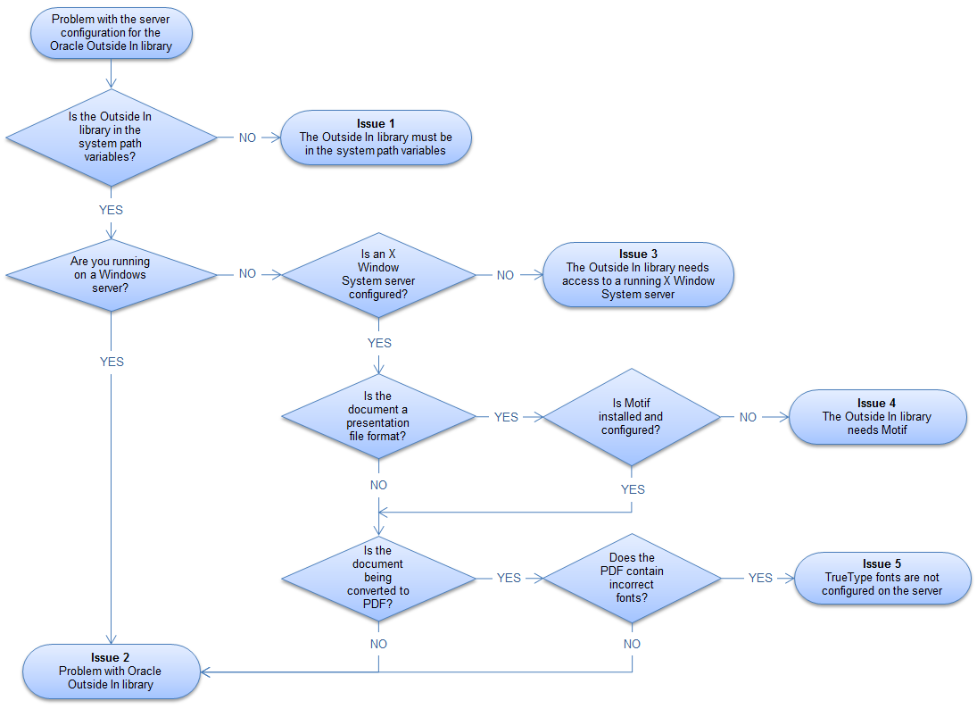

*Figure 7 - Flowchart for determining why the Oracle Outside In library is not working*

|  |  |  |
| --- | --- | --- |
|  | You have determined that the problem is with… | What to do next… |
| 1 | Outside In library is not in the system path variables | See Adding the Oracle Outside In library to the system path variables. |
| 2 | Oracle Outside In library | Enable debug logging on the IBM Content Navigator server and contact IBM Software Support. For more information, see [Enabling server logging for IBM Content Navigator](http://pic.dhe.ibm.com/infocenter/p8docs/v5r2m0/topic/com.ibm.installingeuc.doc/eucts002.htm). |
| 3 | Outside In library does not have access to a running X Window Server system | See Configuring access to a Window X System server |
| 4 | Motif is not installed and configured | See Configuring Motif. |
| 5 | TrueType fonts are not configured on the server | See Configuring TrueType fonts. |

## Adding the Oracle Outside In library to the system path variables

The Oracle Outside In library is installed with IBM Content Navigator. You must add the path to the Outside In library to the web application server environment variables to enable HTML and PDF file conversions.

To add the Oracle Outside In library to the system path variables, complete the appropriate task for your environment:

* [Enabling HTML and PDF file conversions in IBM Content Navigator (WebSphere Application Server)](http://pic.dhe.ibm.com/infocenter/p8docs/v5r2m0/topic/com.ibm.installingeuc.doc/eucde007.htm)
* [Enabling HTML and PDF file conversions in IBM Content Navigator (Oracle WebLogic Server)](http://pic.dhe.ibm.com/infocenter/p8docs/v5r2m0/topic/com.ibm.installingeuc.doc/eucde008.htm)

To verify that the Oracle Outside In library was added to the system path variables, run the verify.jsp tool. For more information, see Verifying your viewer configuration by running the verify.jsp tool and Verify OutsideIn Install.

## Configuring access to a Window X System server

On Linux, Linux for System z, and AIX, the Oracle Outside In library needs access to a running X Window System server to convert vector graphics to PDF and HTML and for previewing vector graphics.

To configure access to a Window X System server, complete [Configuring access to an X Window System server](http://pic.dhe.ibm.com/infocenter/p8docs/v5r2m0/topic/com.ibm.installingeuc.doc/eucde029.htm) in *Planning, Installing, and Configuring IBM Content Navigator*.

To verify the Window X System server configuration, run the verify.jsp tool. For more information, see Verifying your viewer configuration by running the verify.jsp tool and Verify OutsideIn Install.

The following graphic shows the DISPLAY setting in the output from the verify.jsp tool.

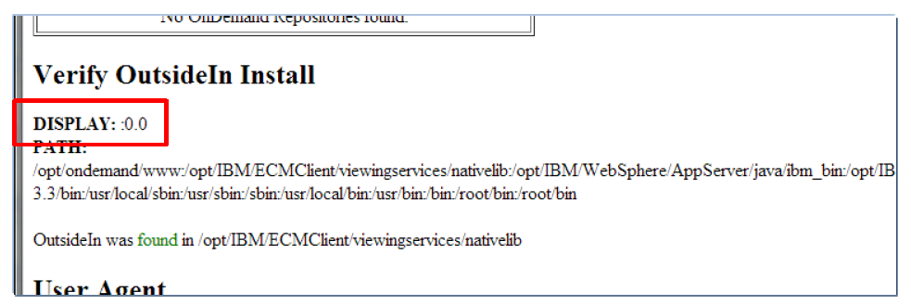

*Figure 8 - Sample output from the verify.jsp tool showing the DISPLAY setting*

To confirm that the Window X System server is running and that you can connect to it from the IBM Content Navigator server:

1. From the command prompt enter:  
   export DISPLAY=display_setting_from_verify.jsp  
   For example, enter:  
   export DISPLAY=:0.0
2. Run the **xlsfonts** command to confirm that you can connect to the Window X System server. Enter:  
     
   xlsfonts

## Configuring Motif

On Linux, Linux for System z, and AIX, the Oracle Outside In library uses Motif libraries to render presentation files, such as PowerPoint documents and Lotus Symphony presentation documents.

### Configuring Motif on Linux and Linux for System z

To verify that Motif is installed on Linux and Linux for System z, enter the following command from the command prompt:

rpm –qa | grep –i motif

If Motif is installed, the command will return a list of packages.

If Motif is not installed on the server, install the 64-bit version of the packages for your operating system. For Linux and Linux for System z, you can download Open Motif packages from the Open Group at <http://www.opengroup.org/openmotif/downloads.html>.

### Configuring Motif on AIX

To verify that Motif is installed on AIX, enter the following command from the command prompt:

lsllp –L | grep –i motif

If Motif is installed, the command will return a list of packages.

If Motif is not installed on the server, install the 64-bit version of the packages for your operating system. For AIX, you can download Motif packages from IBM at <http://www.ibm.com/support/docview.wss?uid=isg1fileset-1208172080>.

## Verifying library dependencies

On Linux, and Linux for System z, and AIX, the Oracle Outside In library requires the presence of other libraries to function correctly.

**Before you begin**

Before you can verify the library dependencies, you must add the Oracle Outside In library to the path system variables on your IBM Content Navigator server. For more information, see Adding the Oracle Outside In library to the system path variables.

To verify library dependencies:

1. Open a command prompt and change to the viewingservices/nativelib subdirectory of the IBM Content Navigator installation directory.
2. Run the **ldd** (list dynamic object dependencies) command on the following libraries:
   * libos_xwin.so  
     Enter: ldd libos_xwin.so
   * libsc_ut.so  
     Enter: ldd libsc_ut.so
   * libex_html.so  
     Enter: ldd libex_html.so
   * libsc_img.so  
     Enter: ldd libsc_img.so

When you run the ldd command for a library, the output includes the list of all of the dependencies and the location of each dependency. If a dependency is not found, the output includes this information.

For the Oracle Outside In library to function correctly, all of the dependencies for each library must be found.

## Configuring TrueType fonts

When a document is converted to PDF or downloaded as a PDF, Oracle Outside In uses the available TrueType fonts on the server to perform font substitution.   
  
**Remember:** Download as PDF and the PDF conversion viewer are not available on AIX or Linux for System z.

On Windows and AIX, there are typically a number of TrueType fonts installed and available. This means that the PDF file that Oracle Outside In generates is likely to look similar to the source document.

However, on Linux and Linux for System z, there are typically fewer TrueType fonts installed. If the PDF file that Oracle Outside In generates does not look similar to the source document, you need to install additional TrueType fonts to fix the problem. Refer to your operating system documentation and to the Oracle Outside In documentation to determine which how to obtain supported TrueType fonts.

On Linux and Linux for System z, after you install the TrueType fonts you must add the directories that contain the TrueType fonts to the GDFONTPATH environment variable. When you run the verify.jsp tool, the output includes the value that is specified for the GDFONTPATH environment variable. For more information, see Verifying your viewer configuration by running the verify.jsp tool.

# Verifying your viewer configuration by running the verify.jsp tool

IBM Content Navigator includes a diagnostic tool called verify.jsp that you can use to identify problems with your viewers.

To run the verify.jsp tool:

1. Stop the IBM Content Navigator web application.
2. Edit the verify.jsp file on the IBM Content Navigator server to remove the two forward slashes before the ENABLE_VERIFY = true entry. By default, the verify.jsp file is in the configure\explodedformat\navigator\viewers subdirectory of the IBM Content Navigator installation directory.
3. Save your changes to the verify.jsp file.
4. Rebuild and redeploy IBM Content Navigator. For more information, see [Updating a deployment](http://pic.dhe.ibm.com/infocenter/p8docs/v5r2m0/topic/com.ibm.installingeuc.doc/eucde024.htm).
5. From a web browser, enter the URL of the verify.jsp page. The URL should have the format http://*server_name*:*port_number*/*context_root*/viewers/verify.jsp. By default, the context root is navigator.  
     
   **Tip:** The format of the URL can vary depending on your environment:  
   * If you deployed IBM Content Navigator to a highly available cluster, the URL must point to the load balancing server: http://*load_balancer_host_name*:*load_balancer_port_number*/*context_root*/viewers/verify.jsp.
   * If you are using SSL, the protocol of the URL is HTTPS: https://*host_name*:*port_number*/*context_root*/viewers/verify.jsp.
   * If you are using Tivoli Access Manager for e-business for single sign-on (SSO), the URL is http://*TAM_server_name*/*context_root*/viewers/verify.jsp.

## Output of the verify.jsp tool

The verify.jsp tool provides information on the following aspects of your IBM Content Navigator configuration:

* ViewONE Pro configuration
* XSLT (Extensible Stylesheet Language Transformations) configuration
* AFP2PDF conversion viewer configuration
* Oracle Outside In installation and configuration
* Client workstation user agent data
* Plug-ins installed on the client workstation

### Verify ViewONE Pro

The **Verify ViewONE Pro** section of the verify.jsp file contains information about your ViewONE Pro configuration.

This section identifies the location and validity of the configuration files that are used by the FileNet viewer (Daeja ViewONE Pro).

* The first row identifies the expected location of the FileNet viewer configuration files.
* The second row identifies the expected location of Daeja Streamer Servlet configuration file, iviewpro.streamer.properties.
* The sixth row identifies the expected location of the Daeja Redaction Servlet configuration file, iviewpro.redacttofile.properties.

The remaining rows in this section verify that the contents of the Daeja Streamer Servlet configuration file and the Daeja Redaction Servlet configuration are correct.

### Verify XSLT

The **Verify XSLT** section of the verify.jsp file indicates whether the XSLT (Extensible Stylesheet Language Transformations) on the IBM Content Navigator server are functioning correctly.

XSLT is required to view and work with annotations in the FileNet viewer. If you see an error in this section, annotations will not work in the FileNet viewer.

### Verify AFP Transform Configuration

The **Verify AFP Transform Configuration** section of the verify.jsp file lists the IBM Content Manager OnDemand repositories in your environment and indicates whether you have an AFP2PDF configuration file associated with each repository.

If you access AFP content on an IBM Content Manager OnDemand repository, the AFP2PDF viewer and the Download as PDF feature require the AFP2PDF conversion tool.

You must specify the location of the AFP2PDF conversion tool in your Content Manager OnDemand configuration in IBM Content Navigator. For more information see [Configuring the AFP2PDF conversion viewer (IBM Content Manager OnDemand)](http://pic.dhe.ibm.com/infocenter/p8docs/v5r2m0/topic/com.ibm.installingeuc.doc/eucco057.htm).

### Verify OutsideIn Install

The **Verify OutsideIn Install** section of the verify.jsp file verifies that the Oracle Outside In libraries, which are installed with IBM Content Navigator, are available for use by the IBM Content Navigator application.

**Remember:** To make the Oracle Outside In libraries available you must Add the Oracle Outside In library to the system path variables.

If you are running IBM Content Navigator on AIX, Linux, or Linux for System z, this section also displays information about the Window X System server that you configured. For more information, see Configuring access to a Window X System server.

### User Agent

The **User Agent** section of the verify.jsp file returns the user agent string that is sent by the web browser that you use to connect to IBM Content Navigator. This information can help IBM Software Support when diagnosing viewer problems.

### Verify Client Side Plugins

The **Verify Client Side Plugins** section of the verify.jsp file contains information about the plug-ins that are installed on the client workstation from which you are accessing IBM Content Navigator.

**Important:** This section includes information about the *client workstation* from which you are accessing IBM Content Navigator. This information might be different depending on the web browser from which you run the verify.jsp tool. Additionally, this information will likely be different depending on the client workstation from which you run the verify.jsp tool.

Specifically, this section checks for the existence of the following plug-ins:

* **IBM AFP viewer plug-in**   
  The IBM AFP viewer plug-in is provided with IBM Content Navigator. To run, the AFP Viewer Plug-In Plus (provided by the IBM Content Manager OnDemand Web Enablement Kit product) must be installed on the client workstation.   
    
  If the AFP Viewer Plug-In Plus is not available, the AFP viewer will not load or will fall back to another viewer, if a fallback viewer is configured in the viewer map for the desktop. See Viewer fallback behavior for more information.
* **Adobe Reader**  
  IBM Content Navigator requires Adobe Reader to be installed on client workstations in order for the following viewers to work:
  + Adobe Reader viewer
  + PDF conversion viewer
  + AFP2PDF viewer

If Adobe Reader is not installed on the client workstation, these viewers will not load or will fall back to another viewer, if a fallback viewer is configured in the viewer map for the desktop. See Viewer fallback behavior for more information.

# Reference Information

## Viewer fallback behavior

When you configure IBM Content Navigator, you create one or more viewer maps to specify which viewer to use to view the different file types in your repository. Each viewer supports a specific set of file types. However, some of the viewers that work with IBM Content Navigator are not supported on every server platform or client platform that IBM Content Navigator supports. In some cases, IBM Content Navigator can automatically select a different viewer to use if another viewer is included in your viewer map. This behavior is called the fallback behavior, and the second viewer is called a fallback viewer. The second viewer must be included in your viewer map to be used as a fallback viewer. You can include multiple fallback viewers in your viewer map.

The fallback behavior of each viewer is listed in [Supported viewers](http://pic.dhe.ibm.com/infocenter/p8docs/v5r2m0/topic/com.ibm.installingeuc.doc/eucco002.htm). The fallback behavior includes information about the conditions under which IBM Content Navigator uses the fallback viewer, if a fallback viewer is configured in the viewer map.